**Nest education IT school**



**2025 Demo-Day**

Kellner Roboter

Our waiter robot

**Table of contents**

List of abbreviations: 3

Members: 3

**Project introduction: 4**

Our project: 4

How we got our idea: 4

Key words: 4

Our plan: 5

How we can use it: 5

How we made it: 6

Conclusion 7

Development 8

Review 8

Materials used 8

## **List of abbreviations:**

* + K.R - Kellner Roboter
  + M.B - Micro: bit
  + M.B.C - Micro: bit code
  + D.D - Demo-Day
  + R.B.C – Ring bit car

## **Members:**

* + Team captain – Tamir
  + Team member - Munkhtugs
  + Team member - Bolor
  + Team member - Gerelt-Od
  + Team member - Bat-Enkh

# **Project introduction:**

## **Our project:**

Our project is Kellner Roboter also known as K.R, what it’s used for is transporting food and carriages efficiently.

## **How we got our idea:**

People use Kellner robots to improve the speed and quality of service, save costs, and attract customers through technological advancements.

## **Key words:**

* Robots
* Waiters

## 

## **Our plan:**

1. First we made the design on how it works and the platform
2. We made the program of how it tracks lines and goes to different seats on M.B
3. We made this work report
4. Bat-Enkh from our team makes the video
5. On D.D we will make a sign that will get attention from

students and get customers and serve them snacks using our K.R

## **How we can use it:**

Our home country Mongolia does not have robots as waiters like other advanced countries, so we decided to make K.R you may ask why it’s useful so here is a list of its superiority:

* It costs less
* It doesn’t make mistakes
* It’s more efficient and faster

## **How we made it:**

We work as a team, and each person works in a different way,

so if they can't do the job on their own, they get help from others.

Our M.B.C:

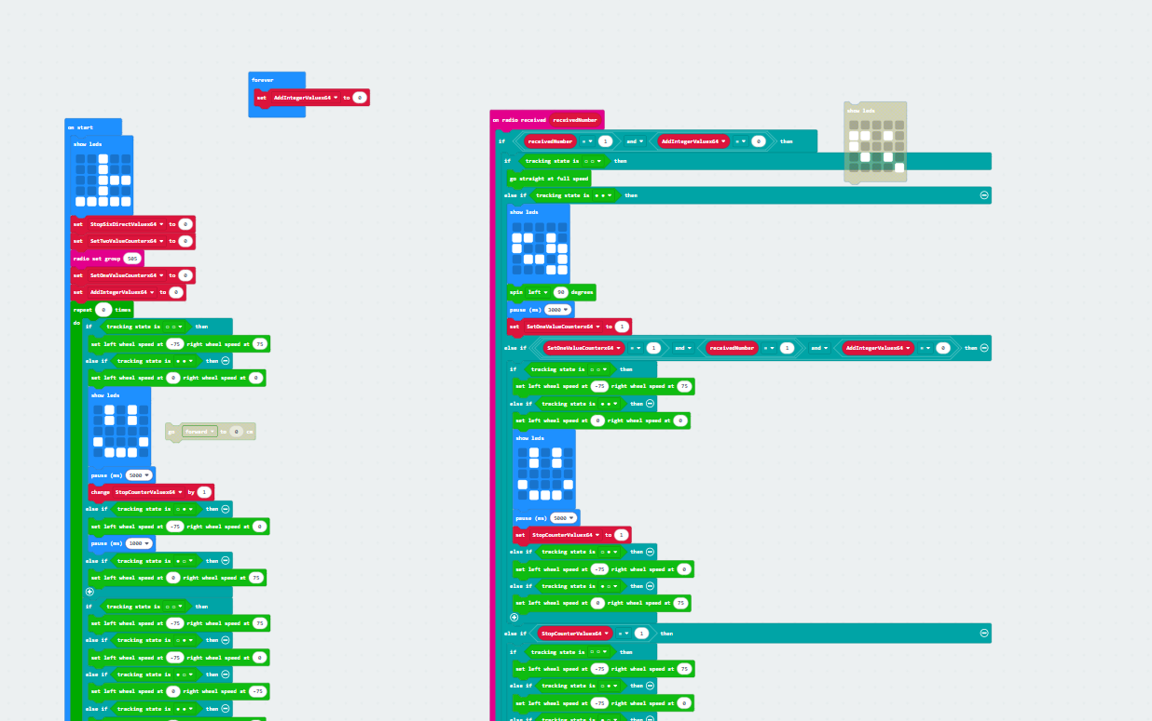

**Testing K.R’s capabilities :**

**Power**

Our LED voltage is 3V, and we used 2 LEDs. A total of 6V was applied.

**Observation**

The first 1-4 attempts were unsuccessful, but from the 5th attempt it worked successfully

Construction.

**Result of our project**

## **Conclusion**

We have improved our project robot through various code and experiments, and have made several improvements by realizing our mistakes. Our coding skills have improved. Everything mentioned in this introduction is included in this robot.

## **Development**

We were able to develop our first robot by teaching the next robot what to do, rather than having it follow a line.

## **Review**

## **Materials used**

We used watt paper and black tape to create our designs, and microbit.com to write the code.